GCP Capstone -2 Project Architect Copilot for Adaptive Retail Layout Design

Abstract
Blue Retail Ventures, a premium electronics retailer, is expanding into dynamic Tier-2 Indian cities like Surat. Their current design process creates generic store layouts that don't align with local consumer tastes, hurting sales. This project will build an AI Co-pilot to solve this by generating conceptual store layouts that are dynamically adapted to real-time local market trends. By using a multi-agent AI system grounded in the company's official documents, the co-pilot will ensure every design is compliant, brand-aligned, and strategically optimized for its specific location.

Background
Blue Retail Ventures is a Mumbai-based retailer known for its high-end consumer electronics and focus on creating an exceptional in-store experience. While successful in major metros, their expansion into new markets has exposed significant inefficiencies in their design workflow.
Key Challenges:
- Slow Design Lifecycle: The manual process of designing and iterating on layouts takes weeks, delaying store openings.
- Lack of Local Context: Centrally designed layouts fail to capture local consumer interests, leading to poor product placement and missed revenue opportunities.
- Compliance Risks: Manually checking each layout against dense brand manuals, building codes, and leasing agreements is tedious and prone to costly errors.
- Scalability Issues: The current human-centric model is too slow and expensive to support the company's goal of opening 50 new stores in the next two years.

Objective
To develop and deploy an AI-powered co-pilot that automates the generation of compliant, locally-adapted conceptual retail store layouts, drastically reducing design time from weeks to minutes.

Problem Statement
Detailed Problem: Blue Retail's architects spend the majority of their time on repetitive tasks: interpreting brand guidelines, ensuring compliance with local codes, and drafting initial block plans. A layout designed for Mumbai might feature products with low search interest in Surat, wasting valuable floor space. Furthermore, misinterpreting a clause in a leasing agreement or an accessibility code can lead to expensive post-construction changes. The fundamental problem is a lack of speed and data-driven intelligence in the initial design phase.

Proposed Solution: We will build a multi-agent system using LangGraph or Google Agent Development Kit (ADK) that simulates a collaborative design team. This "AI Co-pilot" will have specialized agents:
- Market Analyst Agent: Identifies trending products in a specific city using real-time web data.
- Layout Strategist Agent: Uses a RAG pipeline with Weaviate or Pinecone to access documents—brand books, building codes, and leasing agreements—to create a logical layout plan.
- AI Draftsman Agent: Translates the logical plan into a 2D visual diagram.

Solution Implementation Requirements:
- The solution must be hosted on Google Cloud Platform (GCP).
- AI models will be Gemini 2.0 Flash and Google embedding models, accessed via Vertex AI.
- The application must be containerized and deployable on Google Cloud Run.
- The system requires robust logging and traceability using Langfuse or MLflow.
- A simple web interface is needed for architects to interact with the co-pilot.
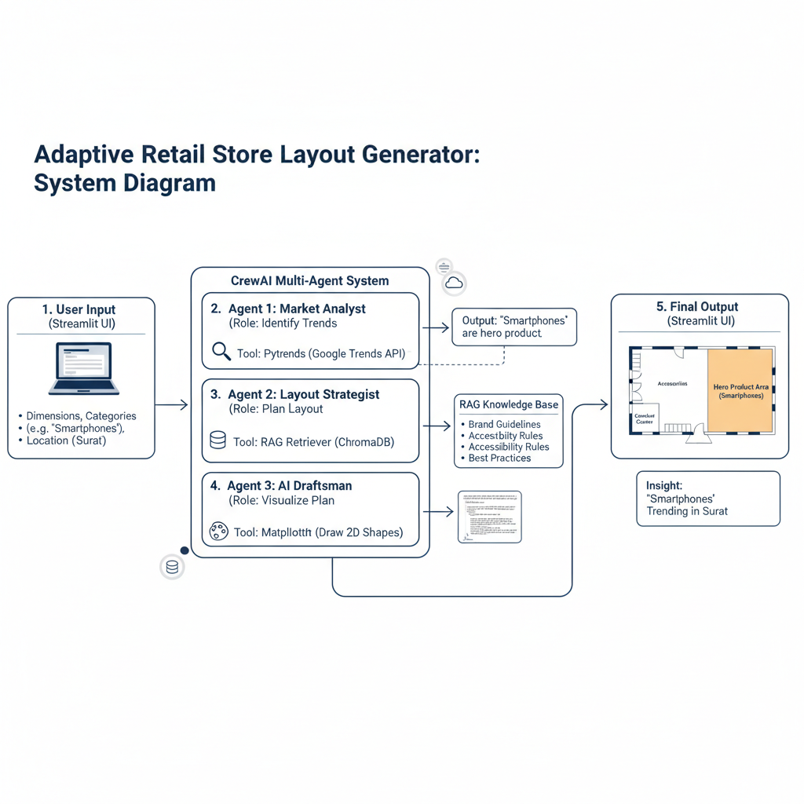

Data Provided
- Documents for RAG Engine (to be indexed in Weaviate/Pinecone):
  - Blue_Retail_Brand_Book_v4.pdf: 50-page brand manual.
  - Fixture_Catalog_Q3_2025.pdf: 80-page catalog with dimensions and specifications.
  - National_Building_Code_Accessibility_Chapter.txt: Text file with excerpts from NBC 2016.
  - Store_Leasing_Agreement_Surat.pdf: 25-page leasing document with critical constraints.
  - Retail_Design_Best_Practices.md: Markdown file with industry principles.
- API Example for Real-Time Data (Google Trends): The "Market Analyst" agent will use the pytrends library to fetch live data.

Solution Design

Phase 1: Foundation & Data Ingestion
- GCP Setup: Set up a GCP Project, enable the Vertex AI API, and provision an Artifact Registry for container images.
- Vector DB Setup: Set up a Weaviate or Pinecone account and create a vector index.
- Data Ingestion Pipeline: Develop scripts to parse documents (.pdf, .txt, .md), chunk them, generate embeddings using Google's models via Vertex AI, and upsert them into the vector index with rich metadata (e.g., source_document: 'Leasing_Agreement').
- Agent Framework Scaffolding: Define the graph structure in LangGraph or Google ADK, including the state object and the nodes for each agent (market_analyst, layout_strategist, draftsman).

Phase 2: Core Agent Development (Layout Strategist)
- RAG Pipeline: Develop the retrieval logic for the Layout Strategist. This involves creating a function that takes a query, generates an embedding, and queries Weaviate/Pinecone to retrieve relevant chunks from all source documents.
- Prompt Engineering: Design and version-control the master prompt for the Layout Strategist, instructing it to synthesize information from all retrieved documents to generate a compliant JSON layout plan. Prompts will be managed in a separate Git repository.
- Output Structuring: Use LangChain's Pydantic output parsers to ensure the LLM's output strictly adheres to the required JSON schema for the layout plan.

Phase 3: Multi-Agent Integration & Tooling
- Market Analyst Agent: Implement this agent as a node in the graph, equipping it with a tool to fetch local trend data using the pytrends library.
- AI Draftsman Agent: Implement the final node. This agent will be a Python function that takes the JSON from the Layout Strategist and uses the Matplotlib library to generate a 2D PNG image of the layout.
Example Output:
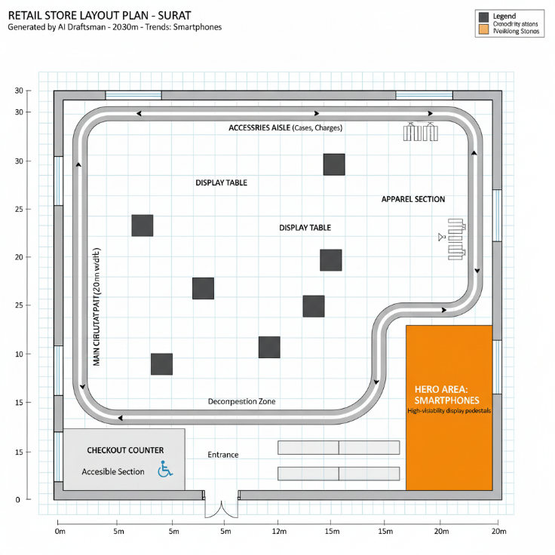
- Graph Compilation: Connect all nodes within the chosen framework. The state will flow from the analyst (adding trend info) to the strategist (adding the JSON plan) and finally to the draftsman.

Phase 4: API & UI Development and Deployment
- API Wrapper: Create a FastAPI wrapper around the agent application, exposing a single endpoint (e.g., /generate_layout).
- Containerization: Write a Dockerfile to package the FastAPI application into a container image.
- Deployment: Push the Docker image to Google Artifact Registry. Deploy the container to Google Cloud Run for a serverless, scalable solution.
- Security: Securely manage API keys and secrets using Google Secret Manager.
- Frontend UI: (Optional) Build a simple Streamlit UI that interacts with the deployed Cloud Run endpoint.

Phase 5: Observability, Testing & Documentation
- Observability Integration: Integrate the Langfuse or MLflow SDK to trace the entire execution flow, providing detailed logs of RAG retrievals, LLM calls, and tool usage.
- Testing: Conduct end-to-end testing to evaluate the quality and compliance of the layouts, especially the agent's adherence to constraints from the leasing agreement.
- Documentation: Create comprehensive documentation covering the system architecture, API usage, deployment process, and a user guide.

Expected Deliverables
- Code Assets:
  - A GitHub repository with all Python source code for the LangGraph/Google ADK agents, data ingestion scripts, and API.
- Deployment Artifacts:
  - Dockerfile for containerizing the application.
  - GCP deployment scripts (gcloud CLI or Cloud Build YAML).
- Observability & Management:
  - A pre-configured Langfuse/MLflow dashboard to trace and monitor agent performance.
  - A separate Git repository for prompt versioning and management.
- Documentation:
  - Technical Design Document outlining the system architecture.
  - User Guide for architects on using the AI Co-pilot.
  - Deployment Manual with step-by-step instructions for deploying on GCP.

Tech Stack
- Cloud Platform: Google Cloud Platform (GCP)
- AI Service: Google Vertex AI (for Gemini 2.0 Flash and Embeddings)
- Orchestration Framework: LangGraph or Google Agent Development Kit (ADK)
- Vector Database: Weaviate or Pinecone
- Deployment: Docker, Google Cloud Run, Google Artifact Registry
- Observability: Langfuse or MLflow
- Prompt Management: Dedicated Git Repository
- API & UI: FastAPI, Streamlit

